April is National Child Abuse Prevention Month: Get involved! | #Unite4Kids
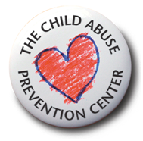

Family Strengthening Toolkit for
Parents & Guardians during
Child Abuse Prevention Month


Each April, people join the national movement to promote Child Abuse Prevention (CAP) Month to raise awareness that child abuse is preventable. Here at The Child Abuse Prevention Center, we prevent child abuse and neglect effectively through safety, education, health and advocacy. For over forty years, the CAP Center has demonstrated a strong record of reducing child abuse cases by 97% among the children and families we serve. We invite you to join us in promoting Child Abuse Prevention Month with a voice loud enough that unifies us all this April, yet will be heard all year long.
___________________________________________________________________________
Tips and Activities:
Children and families make up a large part of the community. We provide parents and guardians the tools and resources needed to raise children in an environment in which they can thrive and succeed.
Please consider implementing some of these tips throughout National Child Abuse Prevention Month and revisit them often throughout the year.
- Volunteer your time: help at your child’s school, read to children at the library, donate to foster youth programs.

- Organize a play day at the local park for the children and families in your area to get to know one another.

- Invite your children to share ideas and implement them to help your community.

- Think safety (home/car/sports) to prevent accidental childhood injuries.
- Get to know new neighbors or new families at your child’s school.
- Organize a “Baby Supplies” drive to collect diapers, formula, car seats, and other supplies for new parents and/or families in need.
- Implement some of these daily acts into your everyday life. Click here for flyer.
- Share Safe Sleep Baby information with families with newborns.
  - Learn and share the ABC’s of Safe Sleep Baby: http://www.thecapcenter.org/what/child-safety/safesleepbaby
  - Watch and share the video: https://youtu.be/wiiDiKwa538
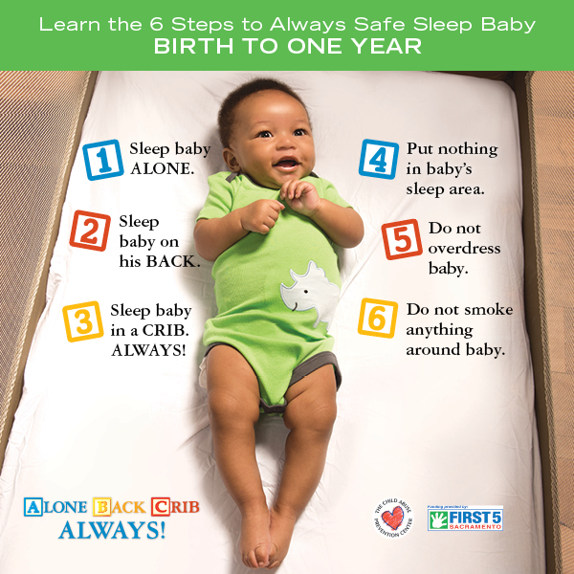
Talking points:
- Children that are raised in loving and supportive environments are more likely to grow up and help create secure, healthy communities and be more productive, prosperous community members.
- Children that are raised in stable families do better academically, are shown to be more financially successful and contribute more to society.
- Abuse can be physical, sexual, emotional and neglect, sometimes all.

- Adverse Childhood Experiences (ACE’s) include things like child abuse (including physical, sexual, and emotional), neglect, parental stress, divorce, parental unemployment, parental mental illness or addiction. Greater than one in four people have experienced at least one ACE, and one in eight have experienced at least four or more ACEs during their childhood. The greater number of ACEs increases the risk of long term adverse consequences. Reducing ACEs leads to positive long-term outcomes for children and communities, including lowering risk for serious health complications and helping children grow into more prosperous and productive adults.

____________________________________________________________________________

____________________________________________________________________________
Wear Blue 4 Kids Day – Friday, April 1
Save and share this postcard:
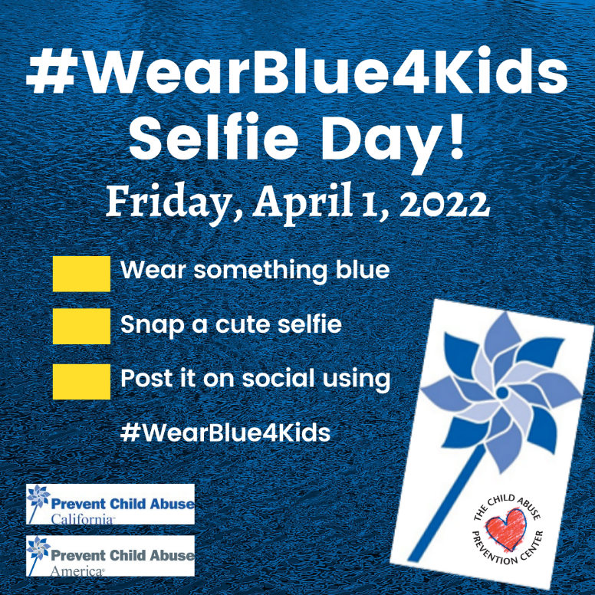

Faith Based Wear Blue 4 Kids Weekend – Friday, April 1 thru Sunday, April 3
Save and share this postcard:
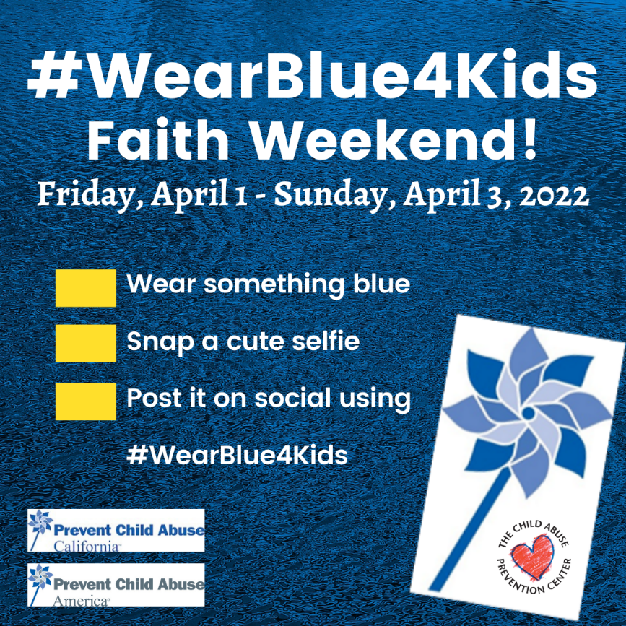

____________________________________________________________________________
Social Media:
Share your CAP Month activities and family strengthening ideas on social media using these hashtags:
#Unite4Kids
#WearBlue4Kids
#CAPmonth
#BeTheOne
Follow and share Wear Blue Friday on social media.
Update your profile pic using Twibbon. Click here to try Twibbon.
____________________________________________________________________________
Tip-sheets for families:
- http://www.thecapcenter.org/what/provide-resources/tip-sheets
____________________________________________________________________________
Why we do what we do:
Every minute in America a child is reported abused or neglected. One in ten is born affected by drugs. One in five is sexually abused. Half a million children are reported abused in California each year. Every day in California at least one child dies as a result of abuse or neglect. Hearts are broken with each death, hopes are destroyed and the promise of a future is lost forever.
In a Centers for Disease Control and Prevention sponsored study, Drs. Anda and Felleti discovered a strong correlation between childhood abuse and subsequent adult diseases including diabetes, obesity, depression, hepatitis, alcoholism, heart disease, fractures and suicide. For people who experienced four or more types of adverse childhood experiences (ACE’s), such as child abuse, the likelihood is increased by:
- 1220% that they will attempt suicide
- 1030% that they will be injection drug users
- 740% that they will be alcoholics
- 220% that they will smoke
- 160% that they will be severely obese
Treatment costs 100 times more than prevention – and it is after the harm has occurred. Invest in your children, your family and your community with prevention. We aren’t searching for a cure. We have evidence-based methods that are proven to reduce child abuse cases by 97% among families served. Prevention works.

To learn more about Child Abuse Prevention Month or other services the Child Abuse Prevention Center provides, please visit www.thecapcenter.org or contact us at (916) 244-1900.

